Call for traineeship
Project/office management at UNICA Secretariat

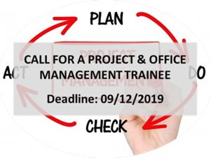
Project & Office management traineeship (application deadline: 9 December 2019)

We are looking for a Master student who will support UNICA in the management of ongoing EU projects, the organisation of UNICA events, the updating & managing of UNICA websites, database & online platforms, the drafting of UNICA publications.

Required: very good verbal and written command of English & writing and communication skills; initiative and enthusiasm to learn; ability to take initiative and to work independently as well as within a team.
Desirable: experience with/notion of European Project management; interest in the EU affairs and policies in the area of HE and Research; knowledge of French is an asset.

The internship will preferably start in January 2020 and will have a duration of minimum 3 months (30 hours per week). Commitments of longer duration (6 months or longer) are preferred.
The position is not remunerated: Apart from Erasmus+ traineeship grant, the trainee will receive a monthly reimbursement of expenses and a monthly public transportation pass.

READ THE CALL

HOW TO APPLY? Candidates are invited to send their CV and a cover letter clearly stating the motivation to work at UNICA and the suitability for the position to: office@unica-network.eu.

